Abhinav Sukhramani

A20392097

Kexun Niu

A20392710

Meghna Bhagwat

A20393668

**Shipperman Trucking Company Online Portal**

**BUSINESS REQUIREMENT**

The main objective of this project is to provide the users with the facility to book trucks for transportation of vehicles to anywhere in Unites States.

There are two perspectives of this portal Admin and Customer.

Customers should be able to create account, view locations and prices, book trucks by selecting from and to location, view order details.

Admin can use the system to add, view, remove employees and locations which will update the front end accordingly. Also an admin can view orders of any user.

Employee can view the orders assigned, update status of the orders to ‘In Progress’ and ‘Completed’ and give feedback.

Once the customer has made the selection the program calculates the total amount and an order is created.

For each order a reference number is generated.

**WEB PAGES**

**Common pages for both users:**

* Register
* Login
* Logout

**For Customer:**

* View Location and Pricing
* Booking
* Payment
* View Order History

**For Admin:**

* View/Remove User
* Add/View/Remove Employee
* Update order status
* View all orders

**ERD**

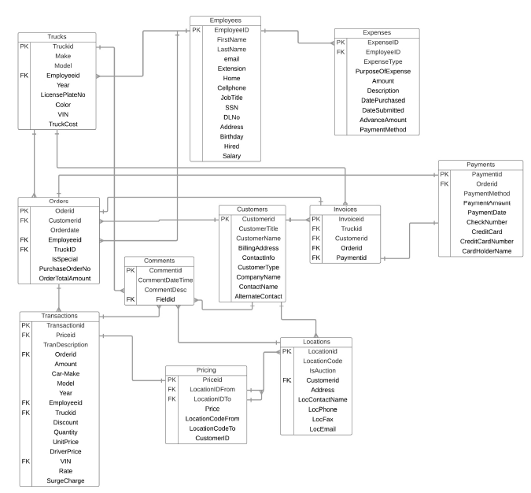

**SCREENSHOTS**

**Welcome**

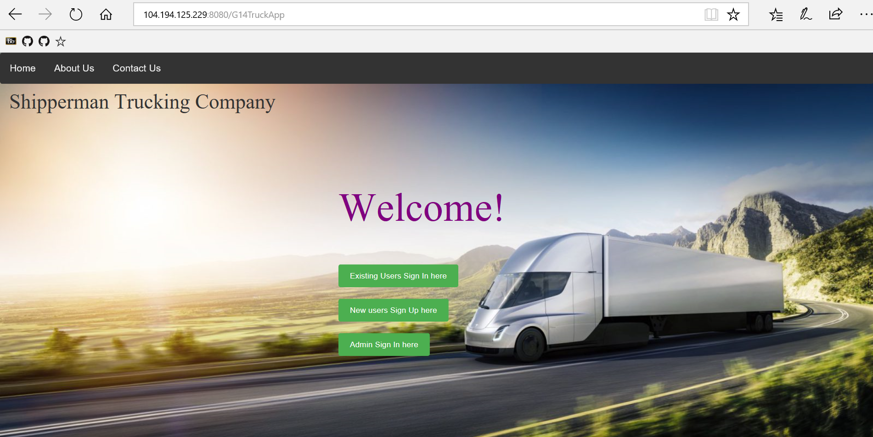

**Login**

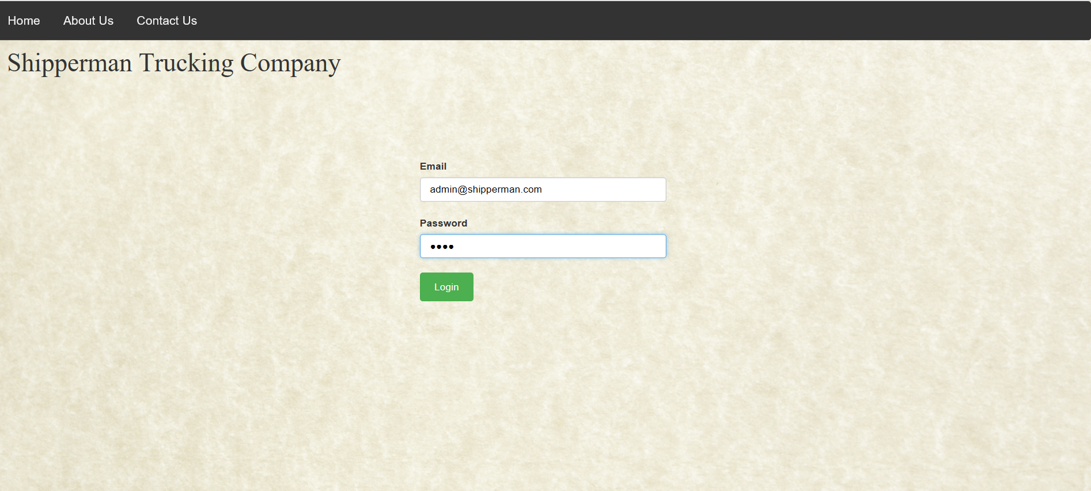

**Home - Admin**

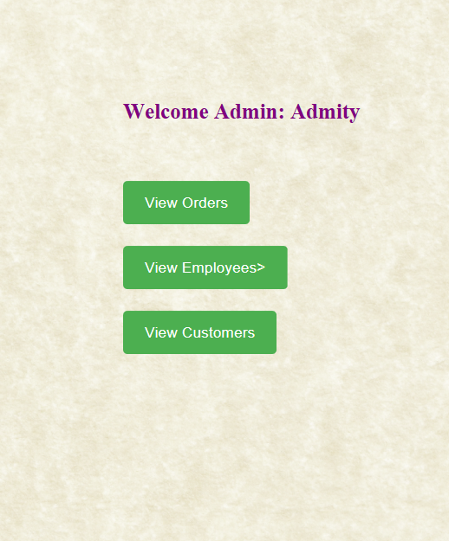

**Employee Management**

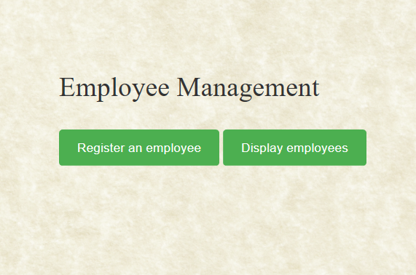

**Display Employees and Remove Employee**

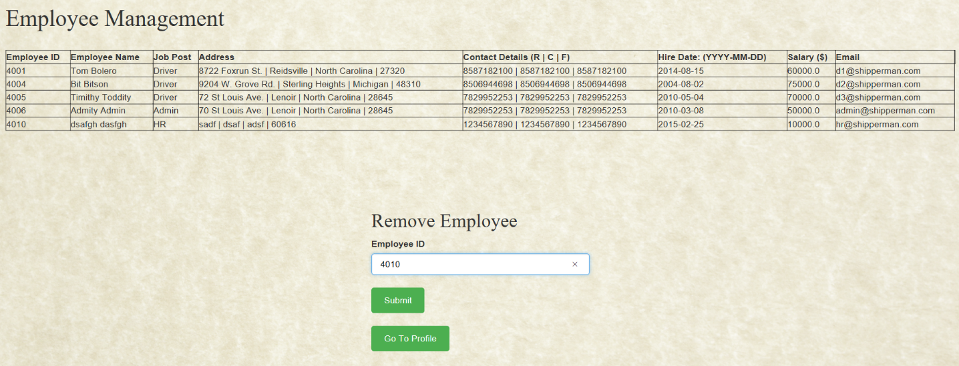

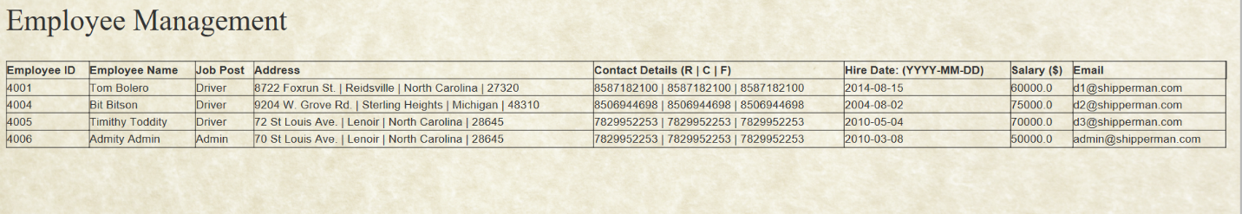

**View Order and Update Order Status**

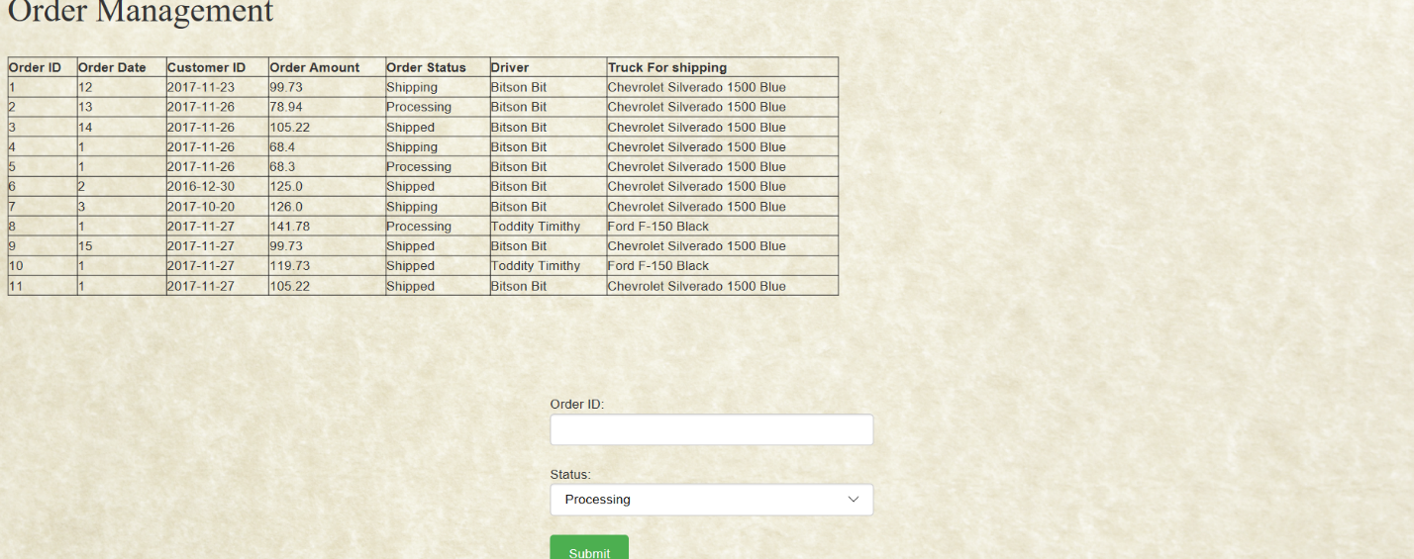

**Home - Customer**

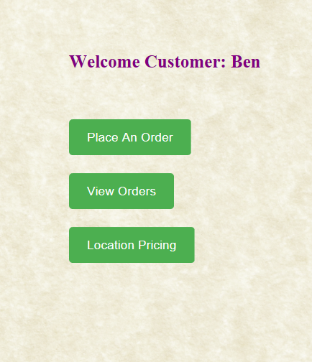

**Place an Order**

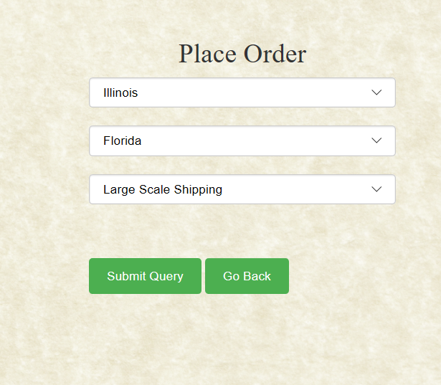

**Check Out**

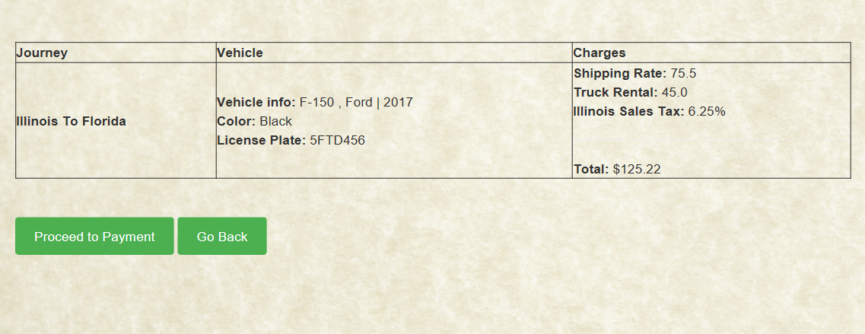

**Payment**

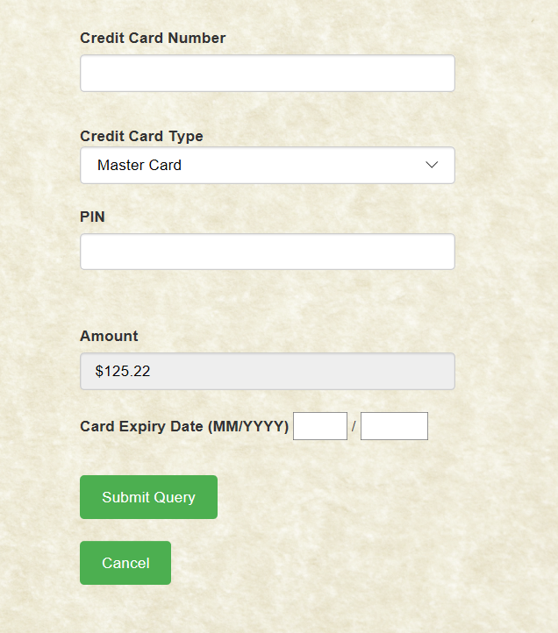

**Card Validation**

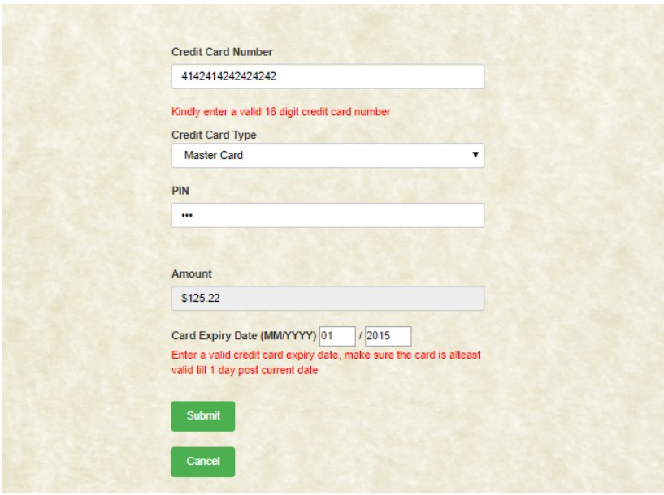

**Order Confirmed**

